Lecture 2
CO1: Apply the knowledge about the concepts of probability and statistics for the computer applications.
CO3: Apply the knowledge about basic ideas of statistics including measures of central tendency, correlation and regression.

Measures of central tendency
Questions such as: “how many calories do I eat per day?” or “how much time do I spend talking per day?” can be hard to answer because the answer will vary from day to day. It’s sometimes more sensible to ask “how many calories do I consume on a typical day?” or “on average, how much time do I spend talking per day?”.
In this section we will study three ways of measuring central tendency in data, the mean, the median and the mode. Each measure gives us a single value? that might be considered typical. Each measure has its own strengths and weaknesses.
Usually when two or more different data sets are to be compared it is necessary to condense the data, but for comparison the condensation of data set into a frequency distribution and visual presentation are not enough. It is then necessary to summarize the data set in a single value. Such a value usually somewhere in the center and represent the entire data set and hence it is called measure of central tendency or averages. Since a measure of central tendency (i.e. an average) indicates the location or the general position of the distribution on the X-axis therefore it is also known as a measure of location or position.
A population of books, cars, people, polar bears, all games played by Babe Ruth throughout his career etc.... is the entire collection of those objects. For any given variable under consideration, each member of the population has a particular value of the variable associated to them, for example the number of home runs scored by Babe Ruth for each game played by him during his career. These values are called data and we can apply our measures of central tendency to the entire population, to get a single value (maybe more than one for the mode) measuring central tendency for the entire population; or we can apply our measures to a subset or sample of the population, to get an estimate of the central tendency for the population.
A sample is a subset of the population, for example, we might collect data on the number of home runs hit by Miguel Cabrera in a random sample of 20 games. If we calculate the mean, median and mode using the data from a sample, the results are called the sample mean, sample median and sample mode.
Sometimes we can look at the entire population, not just a subset. For example, since Babe Ruth has now retired, so we might collect data on the number of home runs he hit in his career. If we calculate the mean, median and mode using the data collected from the entire population, the results are called the population mean, population median and population mode.
Types of Measure of Central Tendency
- Arithmetic Mean
- Geometric Mean
- Harmonic Mean
- Mode
- Median

Arithmetic Mean or Simply Mean: “A value obtained by dividing the sum of all the observations by the number of observations is called arithmetic Mean”
Mean = $\frac{Sum of All observation}{Number of observation}$
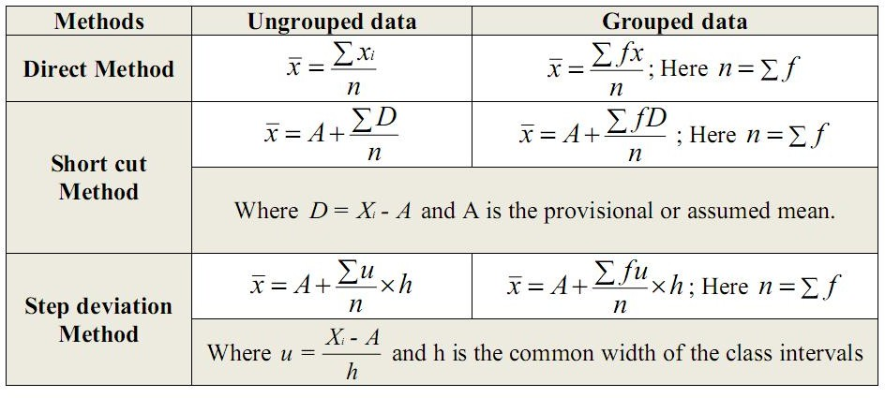

Numerical Example:
- Calculate the arithmetic mean for the following the marks obtained by 9 students are given below:
xi
45
32
37
46
39
36
41
48
36
n
∑ xi = 360
i=1

Using formula of arithmetic mean for ungrouped data:
$$\overline{x}=\frac{\sum_{i=1}^{n}{x_{i}}}{n}$$
n = 9
$\overline{x}=\frac{360}{9}=40 marks$

Numerical Example:
- Calculate the arithmetic mean for the following data given below:
- Using formula of direct method of arithmetic mean for grouped data:
$\overline{x}=\frac{\sum_{i=1}^{n}{{f_{i}x}_{i}}}{\sum_{i=1}^{n}{f_{i}}}$, $n=\sum_{i=1}^{n}{f_{i}}$
The weight recorded to the nearest grams of 60 apples picked out at random from a consignment are given below:
106 | 107 | 76 | 82 | 109 | 107 | 115 | 93 | 187 | 95 | 123 | 125
111 | 92 | 86 | 70 | 126 | 68 | 130 | 129 | 139 | 119 | 115 | 128
100 | 186 | 84 | 99 | 113 | 204 | 111 | 141 | 136 | 123 | 90 | 115
98 | 110 | 78 | 185 | 162 | 178 | 140 | 152 | 173 | 146 | 158 | 194
148 | 90 | 107 | 181 | 131 | 75 | 184 | 104 | 110 | 80 | 118 | 82

Weight (grams) | Frequency
65----84 | 09
85----104 | 10
105----124 | 17
125----144 | 10
145----164 | 05
165----184 | 04
185----204 | 05

Solution:
Weight grams) | Midpoints (xi) | Frequency (fi) | fi xi
65----84 | (65+84)/2=74.5 | 09 | 9 * 74.5=670.5
85----104 | 94.5 | 10 | 945.0
105----124 | 114.5 | 17 | 1946.5
125----144 | 134.5 | 10 | 1345.0
145----164 | 154.5 | 05 | 772.5
165----184 | 174.5 | 04 | 698.0
185----204 | 194.5 | 05 | 972.5
 |  | $$\sum_{i=1}^{n}{f_{i}}=60$$ | $$\sum_{i=1}^{n}{{f_{i}x}_{i}}=7350.0$$

$$\overline{x} =\frac{\sum_{i=1}^{n}{{f_{i}x}_{i}}}{\sum_{i=1}^{n}{f_{i}}} =\frac{7350.0}{60}=122.5 grams$$

- Using formula of short cut method of arithmetic mean for grouped data:
$\overline{x} =A+\frac{\sum_{i=1}^{n}{{f_{i}D}_{i}}}{\sum_{i=1}^{n}{f_{i}}}$, $n=\sum_{i=1}^{n}{f_{i}}$
Where $D_{i} X_{i} A$ and A is the provisional or assumed mean.
Weight (grams) | Midpoint $(x_{i})$ | Frequency $(f_{i})$ | $D_{i}=X_{i}-A,$ A=114.5 | $$f_{i}D_{i}$$
65-84 | (65+84)/2=74.5 | 09 | -40 | -360
85-104 | 95.5 | 10 | -20 | -200
105-124 | 114.5 | 17 | 0 | 0
125-144 | 134.5 | 10 | 20 | 200
145-164 | 154.5 | 5 | 40 | 200
165-184 | 174.5 | 4 | 60 | 240
185-204 | 194.5 | 5 | 80 | 400
 |  | $$\sum_{i=1}{f_{i}}=60$$ |  | $$\sum_{i=1}{f_{i}}D_{i}=480$$

$$\overline{x} =A+\frac{\sum_{i=1}^{n}{{f_{i}D}_{i}}}{\sum_{i=1}^{n}{f_{i}}} =114.5+\frac{480}{60}=122.5 grams$$

- Using formula of step deviation method of arithmetic mean for grouped data:
$$\overline{x} =A+\frac{\sum_{i=1}^{n}{{f_{i}u}_{i}}}{\sum_{i=1}^{n}{f_{i}}}×h$$
$u_{i}=\frac{x_{i}-A}{h}$ Where h is the width of the class interval:

Weight (grams) | Midpoints (xi) | Frequency (fi) | $u_{i}=\frac{x_{i}-A}{h}$ , A = 114.5, h=20 | fiui
65----84 | (65+ 84)/2 = 74.5 | 09 | -2 | -18
85----104 | 94.5 | 10 | -1 | -10
105----124 | 114.5 | 17 | 0 | 0
125----144 | 134.5 | 10 | 1 | 10
145----164 | 154.5 | 05 | 2 | 10
165----184 | 174.5 | 04 | 3 | 12
185----204 | 194.5 | 05 | 4 | 20
 |  | $$\sum_{i=1}^{n}{f_{i}}=60$$ |  | $$\sum_{i=1}^{n}{{f_{i}u}_{i}}=24$$

$$\overline{x} =A+\frac{\sum_{i=1}^{n}{{f_{i}u}_{i}}}{\sum_{i=1}^{n}{f_{i}}}×h=114.5+\frac{24}{60}×20=114.5+08=122.5 grams$$
Properties of Arithmetic Mean:
The following are the properties of arithmetic mean:
- The mean of a constant is that constant.
- The sum of deviations from mean is equal to zero. i.e. $\sum{\left(x_{i}-\overline{x}\right)=0}.$
- The sum of squared deviations from the mean is smaller than the sum of squared deviations from any arbitrary value or provisional mean. i.e. $\sum{\left(x_{i}-\overline{x}\right)<}\sum{{\left(x_{i}-A\right)}^{2}}$
- The arithmetic mean is affected by the change of origin and scale i.e. when a constant is added to or subtracted from each value pf a variable or if each value of a variable is multiplied or divided by a constant, then arithmetic mean is affected by these changes.

Advantages & Disadvantages of Arithmetic Mean
Advantages
- A.M. is readily understood, and hence needs no explanation, when used.
- The computation of A.M. is easy and does not involve any laborious numerical calculations. Even if all observations are not known individually, A.M. can be found, provided their sum and the number of observations is known.
- It can be calculated without arranging the data in order of magnitude (as required for median), or in the form of a frequency distribution (as required for mode).
- A.M. can be treated algebraically. Given the A.M. and the number of observations in each of several groups, A.M. of the composite group can be easily determined by using an algebraic formula.
- It is a very stable and reliable average as regards sampling fluctuations. If many samples are drawn from the same population and each time several measures of central tendency calculated, it will be found that A.M. fluctuates less from sample to sample than any other measures.
Disadvantages
- A.M. cannot be obtained by inspection, as in the case of median or mode.
- It cannot be calculated unless the exact magnitude of all observations and their number is known accurately. If some of the extreme values are missing, the accuracy of A.M. is greatly affected. A.M. cannot therefore be calculated from a grouped frequency distribution with open-end classes, unless some assumptions are made regarding the sizes of these classes.
- The greatest disadvantage of A.M. is that it is highly affected by the presence of even a few extremely large or small observations.
- A.M. may not be an actual value of the variable. (For example, A.M. of the number of children per family may come to 2.54. However, although there may be 2 children or 3 children in a family, 2.54 children is meaningless.)

TEXT BOOKS
- T1 = H. K Dass, Higher Engineering Mathematics, S. Chand Publishers,3rd revised edition.2014.
- T2 = B.S. Grewal, Higher Engineering Mathematics, Khanna Publishers,42th ed.2013, New Delhi.
- T3= N. P. Bali and Manish Goyal, A textbook of engineering Mathematics, Laxmi Publications, Reprint 2008.

REFERENCE BOOKS
- R1=R. K. Jain and S. R. K. Lyenger, Advanced Engineering Mathematics ,3rd Edition Narosa Publishing House ,2004,New Delhi.
- R2 =B. V. Ramana Advanced Engineering Mathematics, McGrawHill, July2006, New Delhi.
- S.P.Gupta,StatisticalMethods,S.Chand&Sons,2017,NewDelhi,ISBN9789351610281Insiders’Guide

Video Lecture:
https://www.youtube.com/watch?v=7cwftEm0DeI&list=PL86hgHi3F9FpPKUuhzw70fKCx1GjWjfxg

